A) What is the maximum BSDF allowable for a scatter contribution from the sun of less than 100picowatts, 1 picowatt?

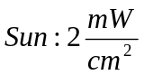

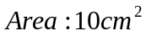

If power from the sun 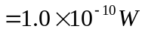

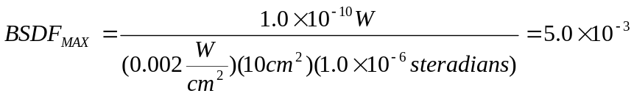

If power from the sun 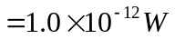

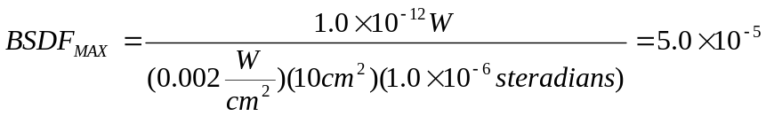

- How does allowable BTDF scale with Aperture area?
The allowable BTDF is inversely proportional to the Aperture area.

C) If we put this imager inside an AlON Dome with the BTDF shown, how close can we the sun be to Bore sight and still produce an input of less than 200picowatts to a pixel?

If power from the sun 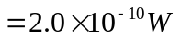

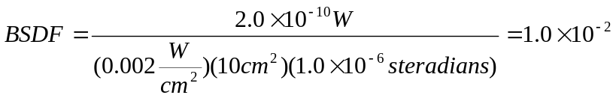

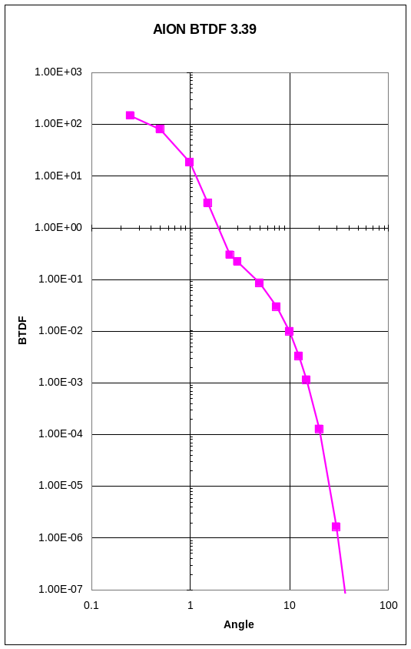

BTDF is 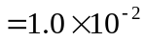 when the sun is 10 degrees off of bore sight

- Assuming the pixels saturate at 4nW/cm² , how far off axis does the sun have to be allow a single pixel to be out of saturation assuming a 512 by 512 array when looking though this dome?

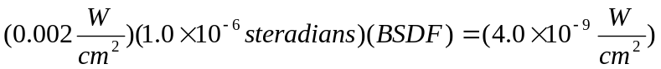

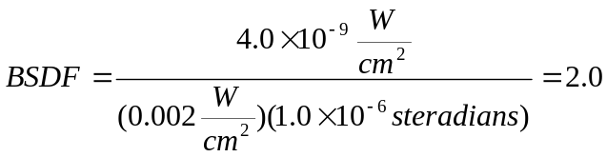

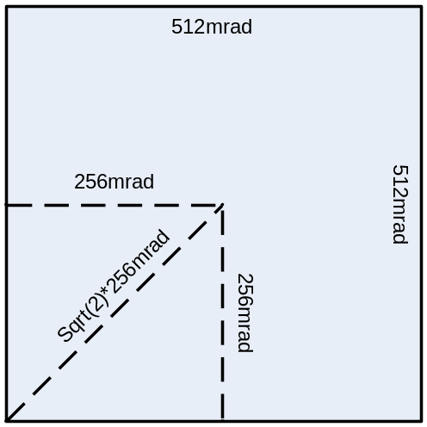
Figure 1) BTDF vs. Angle plot Figure 2) Calculating Sun Angle

A BTDF of 2.0 corresponds to 1.5 degrees from Figure 1. Using Figure 2 we are able to calculate the total amount the sun has to be off axis to cause a pixel to go out of saturation.

